Area of Triangle

Given 3 sets of distinct coordinates that form a triangle, determine the area of the triangle. At least one of the sides will be parallel to the *x* or *y* axis.

**Example**

*x = [0, 3, 0]*

*y = [0, 5, 2]*

Aligned by index, the *3* coordinates are *[0,0], [3,5], [0,2].* The base of the triangle is *2*, and the height is *3.* The area of a triangle is (base * height)/2, so *3 * 2 / 2 = 3*. All resulting areas will be whole numbers.

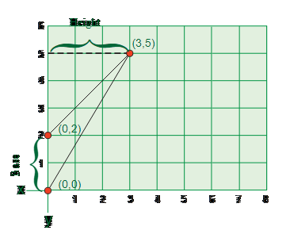

**Function Description**

Complete the function *getTriangleArea* in the editor below.

*getTriangleArea* has the following parameter(s):

*int x [3]: An* integer array that denotes the *x* coordinates.

    int *y[3]:*  An integer array that denotes the *y* coordinates, aligned with *x* by index.

Returns:

    long int:    the area of the triangle

**Constraints**

* 0 ≤ *x[i], y[i]* < 105

**Sample Case 0**

**Sample Input 0**

STDIN    Function   
-----    --------   
3    →   x[] size = 3 (always)   
0    →   x = [0, 3, 6]   
3   
6   
3    →   y[] size = 3 (always)   
0    →   y = [0, 3, 0]   
3   
0 

**Sample Output 0**

9

**Explanation 0**

*The base has a length of 6, and the height is 3. The area is (6 * 3) / 2 = 9.*

**Sample Case 1**

**Sample Input 1**

STDIN    Function   
-----    --------   
3    →   x[] size = 3   
0    →   y = [0, 1, 0]   
1   
0   
3    →   y[] size = 3   
0    →   y = [0, 0, 2]   
0   
2 

**Sample Output 1**

1 

**Explanation 1**

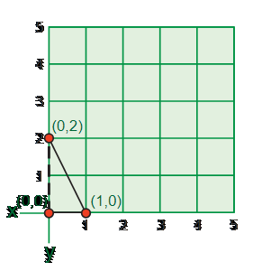

The base of the triangle is 1 and the height is *2,* so the area is *(1 * 2) / 2 = 1*.